SYSTEM REQUIREMENTS SPECIFICATION (SRS) DOCUMENT

Version: | 1.0
Client: | COMESA
Date: | 08/06/2020

Revisions
Version | Primary Author(s) | Description of Version | Date Completed
1.0 | Joshua Amolo | First Draft for Comments | 09/06/2020

Review & Approval
Approving Party | Version Approved | Signature | Date
Amb. Kipyego Cheluget, ASG-P & Chair Task Force on platform development | V1
Lanka Dorby, Director IT | V1
Dr. Christopher Onyango, Director Trade & Customs | V1
Joshua Amolo -Information Systems Analyst, COMESA (IT Lead) | V1
Ahmed Salih, Cordinated Border Management Expert (Trade Lead) | V1

Requirements Document Review History
Reviewer | Version Reviewed | Signature | Date
COMESA Team | V1 | First Version

INDEX
1 Introduction 4
1.1 Purpose 4
1.2 Intended Audience 4
1.3 Scope 4
1.4 Definition, Acronyms, and Abbreviations 4
2 Overall Description 6
2.1 System Perspective 6
2.2 System Functions 7
2.3 User Classes and Characteristics 8
2.4 Operating Environment 8
2.5 User Documentation 8
2.6 Assumptions and Dependencies 8
3 Specific Requirements 9
3.1 External Interface 9
3.1.1 User Interface 9
3.1.2 Hardware Interface 10
3.1.3 Software Interface 11
3.1.4 Communication Interface 11
3.2 Functional Requirements 11
3.2.1 Portal content structure 12
3.2.2 REQ-16: Permissions, Roles and Workflow 17
3.2.3 REQ-17: Search 17
3.3 Use Cases 17
3.4 Non-Functional Requirements 19
3.4.1 Performance Requirements (scalability, speed & security) 19
3.4.2 Safety Requirements 19
3.4.3 Security Requirements 20
3.4.4 Software Quality Attributes 20
4 Other Requirements 21
4.1 Web analytics reporting tool 21
5 Appendices 22

Introduction

Purpose
The purpose of this document is to provide information to the COMESA Management and Procurement Committee sufficient to allow their endorsement of the development, maintenance, hosting, and use of an on-line platform for Member States to Exchange information on availability of essential products and share information relevant to management of COVID 19 pandemic.

Intended Audience
The intended audience of this document is the task force on the development of the platform, IT experts, trade experts and the executive management. The document explains the high-level technical and functional requirements and provides information about the roles and responsibilities needed to support such a system, including the obligations of COMESA Secretariat and the obligations of other parties.

Scope
This Functional and Technical Requirements Document outlines the functional, performance, security and other system requirements identified by the Task force on the platform development highlighted in the Concept Note as the proposed information system solution for the online platform.
The scope of this work includes the initial development of the online platform, based on information and feedback gathered during the COMESA Extra-ordinary Council on COVID 19 and meetings of the task force on COIVID 19. References to future development considerations are included in this proposal for information purposes only.

Definition, Acronyms, and Abbreviations
“TORs” Means the Terms of Reference that explain the objectives, scope of work, activities, and tasks to be performed, respective responsibilities of all parties involved in the development, and expected results and deliverables of the assignment.
COMESA Common Market for Eastern and Southern Africa
COVID 19 Corona Virus Disease 2019
EAC East African Community
SRS System Requirements Specification
SDD System Design Document
QA Quality Assurance
BBDD Database
REQ Requisite
iOS iPhone Operating System

Overall Description

System Perspective
As part of its COVID - 19 mitigation strategy COMESA convened the 8th extra-ordinary meeting of Council of Ministers which was held virtually on the 14th May 2020 to adopt regional guidelines developed to facilitate movement of goods and services across the region during the COVID-19 pandemic. The principal aim of the COMESA COVID Guidelines is to provide for common measures to be applied across the COMESA region covering its 21 COMESA states to facilitate an un-interrupted movement of goods and services across its borders. To ensure a seamless application of trade facilitation measures in the region, the measures were crafted to complement those adopted by sister Regional Economic Communities, specifically the East African Community, the Southern African Development Community and the African Union.
The extra-ordinary meeting of the COMESA Council of Ministers, amongst its key decisions directed the Secretariat to develop, as soon as possible, an online platform for exchanging and sharing information on availability of essential products within the COMESA Member States as part of the response measures to the COVID-19 pandemic.
In this regard, the Secretariat is commencing implementation of the urgent Council decision the Secretariat to establish an online platform on its website (a COVID 19 resource page). The web page aims to facilitate regional electronic information sharing for its 21 Member States on the availability as well as demand for essential and other products and services that maybe in critical shortages akin to a COVID 19 supply portal. The system will be a COVID- 19 business facilitation solution for the COMESA region. The portal is intended to bring the 21 Member States and its business community to a virtual information platform of essential COVID -19 products. The platform will help the Member States, citizens of COMESA and the business community to have information about countries with shortages, countries with available supplies and as well as facilitate the contacts of suppliers and buyers of goods and services, wherever they are within the region, in real time at a lower cost. . The online platform is also expected to compliment the implementation of the COMESA COVID-19 Guidelines to facilitate movement of goods and services in the region at the same time to contribute to poverty reduction in the Member States.
The COMESA Online Platform for Exchanging, and Sharing Information will have the following features;
- COVID-19 Regulations and guidelines put in place by member states (Each Member state may upload or send copy to Secretariat for uploading immediately regulation/Measure is gazetted)
- COMESA COVID-19 Guidelines and reports
- Data reporting based on the reporting template in Annex 1 to the COMESA Guidelines on COVID-19 built in the portal for online population by Member States
- COVID-19 focal persons and teams in MS and their contact details
- Listing of COMESA Manufacturers/Producers/Suppliers authorized and approved by their respective Member State to export essential products
- Listing of Products on offer by various manufacturers/suppliers
  - MS/Authorized suppliers may post products including pictorial messages, pricing, product specifications, contact details and names of persons to be contacted
  - Stock availability/enquiries to be updated on the platform
- Products on demand enquiries – Responsible Government agency or Private company of the MS to post/update their demand of products on the portal
- Useful links – Link to all relevant websites in the MS
- Any other relevant information that may be determined from time to time by the task team on COVID 19

System Functions
The major features the system contains or the significant functions that it performs or lets the user perform are:
- facilitate national authorities (and all importers and exporters within COMESA) to indicate shortages, availability and requests for supplies of essential goods and services under the existing COVID circumstances;
- facilitate the Member States, through designated Contact Points, of the information required in terms of products sought/available, the traders of the products (importers and exporters) including SMEs and possible linkages to those traders.
- Statistical reporting on trade in the COVID-19 essential goods and services within the region as reported by the Member States

User Classes and Characteristics
The main users of the platform will be Member States through their nominated focal persons, Manufacturers & Suppliers of essential products, COMESA Secretariat and the public.
The platform therefore must be user friendly.

Operating Environment
The architecture in which the system will operate are describe below;
- Balancer and cache cluster for load balancing to different front nodes.
- Apache Web Servers.
- Backend system composed of:
  - NFS cluster for central storage.
  - Index and search cluster for searches.
  - High availability database e.g. MariaDB

COMESA shall provide a high availability hosting platform either custom built on premise or outsourced on cloud via Rackspace or Microsoft Azure Platform.

User Documentation
Owing to strict timelines attached to the development and operationalization of the platform, the following documents shall be created immediately:
- System Requirements Specification (SRS)
- Technical Documentation:
  - User Guide
  - Administrator Guide
  - Developer Guide (After launch)

Assumptions and Dependencies
The platform shall support the official COMESA languages – Arabic, English and French.

Specific Requirements

External Interface

User Interface
The system shall be accessed via web clients with adaptation to other devices like tablets and phones:
The user interface will be easy and intuitive: user interfaces will be designed in accordance to end user needs.

Mobile Access
Web Application Access
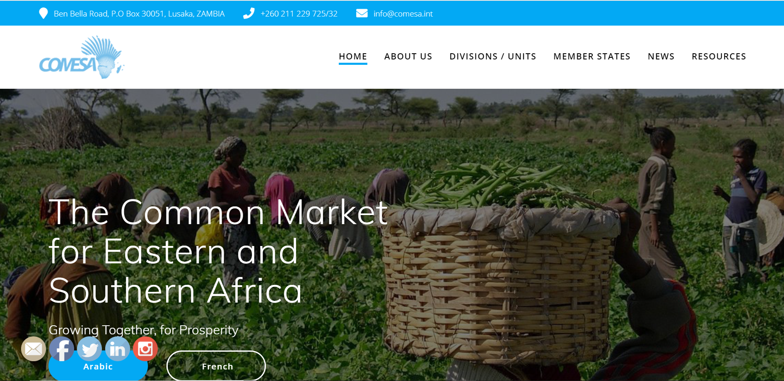

Hardware Interface
Some of the components of the hardware interface are.
- Virtualized Infrastructure
- Cloud Architecture (Private/Cloud)
- Backup and Storage
COMESA Secretariat shall make a decision on the best hosting platform once usage and performance has been monitored over a period of time.

Software Interface
The software component and their versions are:
Web Application
- Development platform: Drupal/Wordpress/Liferay/Alfresco/Laravel/CodeIgniter/Symfony
- Database: MariaDB 10.3+
- Application server: Apache Tomcat
- Java SE Development Kit 7/PHP
- Web server: Apache Http Server 2.4/Nginx
- NFS server (last of the official repository)
- Elasticsearch
Operating System
- CentOS 7.x/Ubuntu

Communication Interface
The platform shall be accessible across various browsers e.g. Mozilla Firefox, Google Chrome, Internet Explorer, Safari e.t.c. In addition, the platform will be accessed via mobile phones.
Using caching technologies, the platform shall be designed to enable it load with minimal bandwidth requirements.

Functional Requirements
In line with decision 23 (ii) of the 8th Extra-ordinary meeting Council, the COMESA COVID- 19 Platform will be a Resource Page for exchange and sharing of information on supply and demand for essential goods and services for potential sourcing and by regional importers including SMEs in the Member States for the benefit of COMESA citizens. The Platform will contain any other COVID- 19 related trade information to facilitate real time availability of information to Member States. Due to the nature of traded products and the mode of transactions, business access shall be restricted to government to government processes.
Specifically, the platform will be;
- a purpose-built tool to facilitate national authorities (and all importers and exporters within COMESA) to indicate shortages, availability and requests for supplies of essential goods during the COVID 19 pandemic;
- used by the Member States, through designated Contact Points, of the information required in terms of products sought/available, the traders of the products (importers and exporters) including SMEs and possible linkages to those traders
- used to track trade on COVID-19 essential goods and services within the region as supplied by Member States

Portal content structure
The platform shall have two main areas; Publicly available information Area and Restricted Access Areas.

public information Area
The public information area is accessible to the public and shall not require user registration to access.

REQ–1: COMESA Guidelines on Movement of Goods and Services during COVID 19
A listing of all the COMESA guidelines and its annexes – static information but may be updated as and when needed (Access restricted to COMESA Secretariat designated staff).

REQ-2: List of Essential Goods
List of all essential goods as classified under the COMESA guidelines. The list can be categorized i.e. foodstuff, medical equipment, medicines e.t.c

REQ-3: MS Guidelines, Measures and Reports
Guidelines, measures and Reports from Members States:
- MS COVID 19 situation brief
- Measures to curb the spread
- Reports
- Bulletins

REQ-4: Public Health and Safety Guidelines
Listing of all Public Health and Safety Guidelines specific to a Member State – can be added, amended, deleted by designated focal person at a specific Member State.

REQ-5: Statistics on COVID 19
Publications of statistics from the time first case was reported.

REQ-6: Bulletins
Listing of all bulletins, gazettes, presidential addresses.

REQ-6: National Task Teams
Listing of National Task Teams

REQ-6: Focal Persons and their Contacts
Contact addressed of all Focal Persons at Member State Level

REQ-6: Useful Links
Useful Links which provide information related to COVID 19

Information Sharing and Exchange Area
This section is restricted based on granular role assignment to users.
This area includes the following sections:
  - Account Management
    - Login/Registration
    - Account Validation and Approval
    - Types of Accounts
      - COMESA Secretariat (Super Admin)
      - Member State Focal Contact (Admin)
      - Manufacturer (User)
      - Supplier
  - Products
    - Categories
    - Specifications
    - Pricing
    - Production/Order quantities
    - Availability Status
  - Manufacturer/Suppliers
    - Profile
    - Address
    - Business Registration
    - Manufacturing/Export Authorization
    - Primary Contacts
  - Product Requests (Available to all authorized Users from MS)
    - Select Products Needed from list of approved Manufacturer (s)
    - Add products to List
    - Send Enquiry to Supplier
  - Product Enquiry Responses (Available to Manufacturers/Suppliers)
    - Enquiry Listings
    - Respond Based on Avalability
- Statistics
  - MS report trade of essential goods
    - Dates
    - Quantity
    - MS States traded with
- Member States
  - Listing of All MS

REQ-7: Login/Registration
- The users of the system shall be presented with a login area using email and password.
- Visible Forgot Password Link – this shall be able to send the new password or link to reset password to the registered user email address
- Allow users without accounts to register by providing email address and password to register
- Member State should also have the ability to add a user directly to the platform

REQ-8: Account Validation and Approval
- The system sends an email to confirm the registration request
- The registration is approved at the Member State Level

REQ-9: Types of Accounts (Roles)
- COMESA Secretariat (Super Admin) – Has all the privileges to change configuration to the entire system
- Member State Focal Contact (Admin) – Has all the privileges to manage configuration and data at the Member States Level
- Manufacturer (User) – Has privileges to add products under approved categories, upload manufacturing documents as attachments
- Supplier (User) – Has same privileges as Manufacturer

REQ-10: Products
This section will have a listing of all products which can be supplied as per the guidelines.
- Further the products information shall be as follows
  - Categories – grouping of similar products to allow ease of filtering
  - Specifications – detailed technical information about the product
  - Pricing – indicative prices of the product
  - Production/Order quantities – Available quantities for export
  - Availability Status – whether in stock or supplied on order
  - Reviews – Allow a section for reviews based on previous orders. These reviews will have a star rating (1 – 5) with a brief comment which shall be published to assist other interested potential buyers

REQ-11: Manufacturer/Suppliers
This section lists all Manufacturers or suppliers based on a selected Member State. Further, this section shall contain the following information;
- Profile – Business profile
- Address – physical address
- Business Registration - business registration information including attached documentations
- Manufacturing/Export Authorization
- Primary Contacts – email, phone

REQ-12: Product/Information Requests
This section will have a listing of all the requests from other Member States. It shall be accessible to all users designated as Member States Focal persons;
- Any authorized user can Select Products Needed from list of approved Manufacturer (s) in any Member State they select to deal with
- Add products to List – the various products are added to a list
- Send Enquiry to Supplier – the list is sent to the various suppliers/manufacturers and enquiry sent to the Member State Focal persons for follow up as well, with email notifications and systems notifications

REQ-13: Product Enquiry Responses (Available to Manufacturers/Suppliers)
This section shall be available to both the Manufacturers, Suppliers and Member States to;
- Enquiry Listings- see all incoming product inquiries
- Respond Based on Availability of product or information requested

REQ-14: Statistics
This section shall be available to both Member States and the Secretariat to be able to trade the movement of the essential goods within the region.
Member States are expected to report trade of essential goods as per the template provided as an annex to the Guidelines. The information shall therefore not be limited to Dates, Quantity, Member States traded with e.t.c.

REQ-15: Share
Users be allowed to share public information on social networks (Facebook, Twitter, LinkedIn, Email and WhatsApp are considered) e.t.c.

REQ-16: Permissions, Roles and Workflow
The following roles shall be available in the system under the Information Sharing and Exchange Area:
- COMESA Secretariat (Super Admin)
- Member State Focal Contact (Admin)
- Manufacturer / Supplier
- Public
Super Admin at the COMESA Secretariat - shall be able to manage the entire configurable sections of the platform.
Admin at the Member State – shall be able to configure all aspects of information at the Member States level including approvals of all self registrations, creation of suppliers and Manufacturers, addition of reports, bulletins, measures e.t.c.
Manufacturer/Supplier – shall be able to respond to queries from Member States as well as updating product information.
Public – View all published information to the public

REQ-17: Search
This section shall provide an search functionality to allow users of the platform search for any information available on the portal

Use Cases
This section describes the actions that the different actors will performs in the system: global (system) administrator, REC content manager, country content manager and end user.
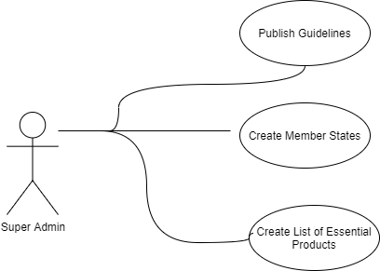
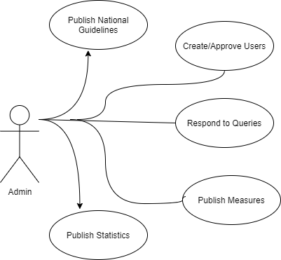

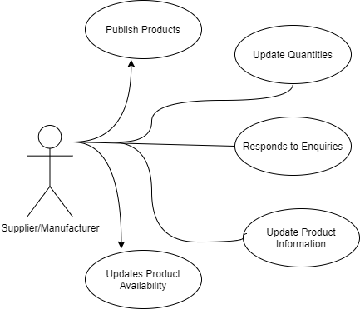

Non-Functional Requirements

Performance Requirements (scalability, speed & security)
The system will support both horizontal scaling (scale out) and vertical scaling (scale up).
The system must support a as many concurrent users as possible.
Load times for the pages must be under 3 – 5 seconds.
The system should also be accessible via all the major browsers (Firefox, IE, Safari, etc.) as well as on the major mobile platforms: Android and iOS.
The platform should allow addition of modules as the usage grows to add functionality.

Safety Requirements
The system will maintain the safety requirements according as defined in the TORs. To avoid data loss, regular backup of all data both at the level of the virtual machines and the information systems ( data in file servers, databases, configuration files) shall be performed to conform with the COMESA Backup Policy.

Security Requirements
The system shall be designed to conform to the security requirements as per the TORs.
In addition, the platform should by default have inbuilt features to prevent attacks from TOP 10 OWASP (Open Web Application Security Project) risks:
- A1:2017-Injection
- A2:2017-Broken Authentication
- A3:2017-Sensitive Data Exposure
- A4:2017-XML External Entities (XXE)
- A5:2017-Broken Access Control
- A6:2017-Security Misconfiguration
- A7:2017-Cross-Site Scripting (XSS)
- A8:2017-Insecure Deserialization
- A9:2017-Using Components with Known Vulnerabilities
- A10:2017-Insufficient Logging &Monitoring.
All the communication between the end user and the platform shall be encrypted using a valid SSL Certificate with minimum 2048 bit of encryption.
Access to the platform will be granted to users based on their roles defined in the permissions matrix.

Software Quality Attributes
The platform will be optimized for using a low bandwidth.
The software quality attributes of the platform shall exhibit usability, robustness, maintainability and interoperability.
The platform should accommodate integration with future development initiatives or existing platforms.

Other Requirements

Web analytics reporting tool
Google Analytics will be used in order to obtain information about KPIs, for example:
• Total monthly traffic.
• Evolution of total traffic.
• Pageviews.
• Evolution of page views.
• Sessions.
• Evolution of the sessions.
• Time of stay in page.
• % Rebound.
• Traffic by sources: direct, organic, referral, paid and social.
• Evolution of traffic by source.
• Most viewed pages.
• Demographic data: sex and age
• Geographical data: location
• Type of connection device
• User behaviour: frequency and assiduity, and interaction.
Other KPIs shall be defined as usage increases.

Appendices
The following documents have been used as reference materials:
- Report of the Extra-ordinary meeting of the Council of Ministers on COVID 19
- COMESA Guidelines on Movement of Essential goods and Services during COVID 19 pandemic
- Task Force Concept Note

